A COMPLETE PIPELINE COMBINING K-MEANS CLUSTERING, AUTOENCODER COMPRESSION,
RESTRICTED BOLTZMANN MACHINES, AND FEEDFORWARD NEURAL NETWORKS
Day 11 Task — Unsuprevised Learning — 26/06/2026
Name: Manish Giri | Reg. No: 137256 | Email: manishgiri8101@gmail.com | [LinkedIn]

Project Architecture
This project applies a multi-stage unsupervised-to-supervised machine learning pipeline on the Titanic dataset. The architecture is designed to discover hidden patterns in passenger data before using them to predict survival.
Component | Description
Dataset | Titanic passenger data (891 rows × 12 columns): Age, Fare, Pclass, Survived, etc.
Phase 1 – Exploration | Load data, remove Survived column, handle missing values, visualize distributions of Age, Fare, and Pclass
Phase 2 – K-Means Clustering | Cluster passengers into 3 groups using Age, Fare, and Pclass. Groups: Wealthy First-Class, Families in Steerage, Solo Young Adventurers
Phase 3 – Autoencoder | 3-layer neural network (Input:3 → Latent:2 → Output:3) to compress features into a 2D latent space
Phase 4 – RBM | Restricted Boltzmann Machine trained on encoded data to extract hidden features: Family Influence & Economic Status
Phase 5 – Neural Network | Feedforward network (5→16→8→1) trained on original + RBM features to predict survival (Accuracy: 75.42%)

Pipeline Flow
The pipeline flows as follows:
Step 1: Raw Titanic CSV | 891 passengers, 12 features
Step 2: Data Preprocessing | Drop Cabin, fill Age (median), fill Embarked (mode), remove Survived
Step 3: Feature Scaling | StandardScaler applied to Age, Fare, Pclass
Step 4: K-Means (k=3) | Cluster passengers → 3 interpretable groups
Step 5: Autoencoder | Compress 3D features → 2D latent space (100 epochs)
Step 6: RBM | Extract 2 hidden features from latent space (50 iterations)
Step 7: Neural Network | Predict Survived with 5 features: original 3 + 2 RBM features
Step 8: Evaluation | Accuracy: 75.42% | Precision/Recall/F1 analysis

Part 1: Data Exploration
Goal: Load the Titanic dataset, understand its structure, remove the target variable (Survived) for unsupervised learning, handle missing values, and visualize key distributions.

1.1 Import Libraries
import pandas as pd
import matplotlib.pyplot as plt
import seaborn as sns

# Display plots inside notebook
%matplotlib inline

# Better plot style
sns.set_style("whitegrid")

1.2 Load Dataset
df = pd.read_csv("Titanic-Dataset.csv")
df.head()
PassengerId Survived Pclass ... Fare Cabin Embarked
0 1 0 3 ... 7.2500 NaN S
1 2 1 1 ... 71.2833 C85 C
2 3 1 3 ... 7.9250 NaN S
3 4 1 1 ... 53.1000 C123 S
4 5 0 3 ... 8.0500 NaN S

[5 rows x 12 columns]

1.3 Dataset Information
print("Shape of Dataset: ", df.shape)
df.info()
Shape of Dataset: (891, 12)
<class 'pandas.core.frame.DataFrame'>
RangeIndex: 891 entries, 0 to 890
Data columns (total 12 columns):
# Column Non-Null Count Dtype
--- ------ -------------- -----
0 PassengerId 891 non-null int64
1 Survived 891 non-null int64
2 Pclass 891 non-null int64
3 Name 891 non-null object
4 Sex 891 non-null object
5 Age 714 non-null float64
6 SibSp 891 non-null int64
7 Parch 891 non-null int64
8 Ticket 891 non-null object
9 Fare 891 non-null float64
10 Cabin 204 non-null object
11 Embarked 889 non-null object
dtypes: float64(2), int64(5), object(5)
memory usage: 83.7+ KB

1.4 Remove Survived Column (Unsupervised Setup)
# Removed the target column (Survived)
unsupervised_df = df.drop("Survived", axis=1)
unsupervised_df.head()

1.5 Handle Missing Values
# Check Missing Values
unsupervised_df.isna().sum()
PassengerId 0
Pclass 0
Name 0
Sex 0
Age 177
SibSp 0
Parch 0
Ticket 0
Fare 0
Cabin 687
Embarked 2
dtype: int64
# Fill Age with median
unsupervised_df["Age"] = unsupervised_df["Age"].fillna(
unsupervised_df["Age"].median()
)

# Fill Embarked with mode
unsupervised_df["Embarked"] = unsupervised_df["Embarked"].fillna(
unsupervised_df["Embarked"].mode()[0]
)

# Drop Cabin — too many missing values (687/891)
unsupervised_df = unsupervised_df.drop(columns=["Cabin"])

1.6 Visualizations
# Age Distribution
plt.figure(figsize=(8, 5))
sns.histplot(df["Age"], bins=30, kde=True, color="skyblue")
plt.title("Distribution of Age")
plt.xlabel("Age")
plt.ylabel("Frequency")
plt.show()
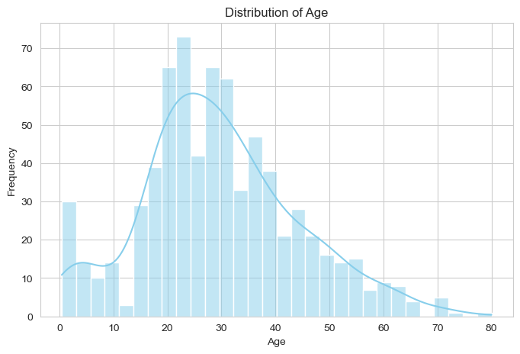
Figure 1: Distribution of passenger ages (most between 20–40 years)
# Fare Distribution
plt.figure(figsize=(8, 5))
sns.histplot(df["Fare"], bins=30, kde=True, color="orange")
plt.title("Distribution of Fare")
plt.xlabel("Fare")
plt.ylabel("Frequency")
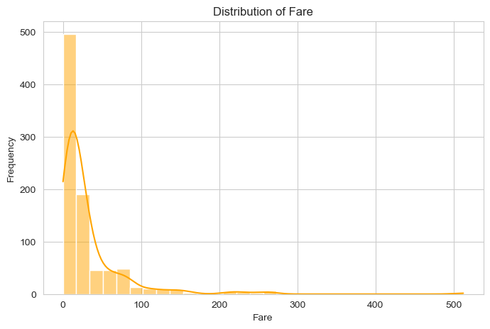
plt.show()
Figure 2: Right-skewed Fare distribution — most passengers paid low fares
# Passenger Class Distribution
plt.figure(figsize=(6, 5))
sns.countplot(x="Pclass", data=df, palette="viridis")
plt.title("Passenger Class Distribution")
plt.xlabel("Passenger Class")
plt.ylabel("Count")
plt.show()
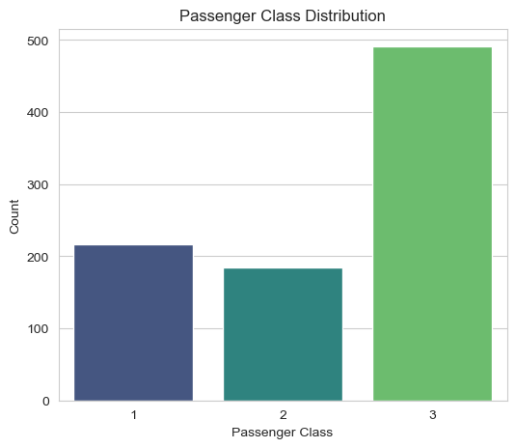
Figure 3: Class 3 (Third Class) had the most passengers
# Summary Statistics
df[["Age", "Fare", "Pclass"]].describe()
Age Fare Pclass
count 714.000000 891.000000 891.000000
mean 29.699118 32.204208 2.308642
std 14.526497 49.693429 0.836071
min 0.420000 0.000000 1.000000
25% 20.125000 7.910400 2.000000
50% 28.000000 14.454200 3.000000
75% 38.000000 31.000000 3.000000
max 80.000000 512.329200 3.000000
💬 Discussion
- Age: Most passengers were between 20–40 years old, with some missing values (177 missing).
- Fare: Right-skewed distribution — most passengers paid low fares with few high-fare outliers.
- Pclass: Third Class (Pclass=3) had the highest passenger count, followed by Second and First.
- Overall: The data is imbalanced, contains missing values (Age) and outliers (Fare). The Survived
- column has been removed, making the dataset suitable for unsupervised learning.
Part 2: K-Means Clustering
Goal: Group passengers by similarity using unsupervised clustering. Apply K-Means with k=3, label clusters, and visualize them using Age vs. Fare.

2.1 Import Libraries
from sklearn.cluster import KMeans
from sklearn.preprocessing import StandardScaler

2.2 Prepare and Scale Features
# Select numerical features
cluster_df = df[["Age", "Fare", "Pclass"]].copy()

# Fill missing Age values
cluster_df["Age"] = cluster_df["Age"].fillna(cluster_df["Age"].median())

# Standardize features
scaler = StandardScaler()
scaled_features = scaler.fit_transform(cluster_df)

2.3 Apply K-Means (k=3)
kmeans = KMeans(n_clusters=3, random_state=42)
cluster_df["Cluster"] = kmeans.fit_predict(scaled_features)

# Cluster summary (mean values per cluster)
cluster_df.groupby("Cluster")[["Age", "Fare", "Pclass"]].mean()
Age Fare Pclass
Cluster
0 14.594952 16.971435 2.802885
1 36.888273 83.765511 1.018182
2 32.419006 14.547469 2.699784

2.4 Name and Visualize Clusters
cluster_names = {
0: "Wealthy First-Class Travelers",
1: "Families in Steerage",
2: "Solo Young Adventurers"
}
cluster_df["Cluster_Name"] = cluster_df["Cluster"].map(cluster_names)

# Plot Clusters (Age vs Fare)
plt.figure(figsize=(10, 6))
sns.scatterplot(data=cluster_df, x="Age", y="Fare", hue="Cluster_Name", palette="Set1", s=70)
plt.title("K-Means Clusters (Age vs Fare)")
plt.show()
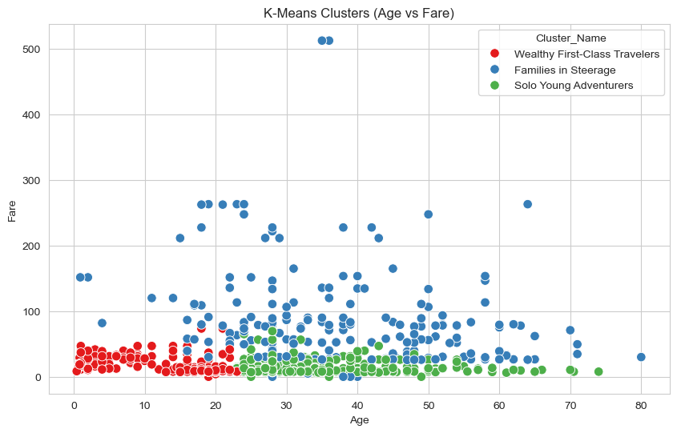
Figure 4: K-Means cluster visualization — Age vs. Fare with 3 distinct passenger groups
# Passengers per cluster
cluster_df["Cluster_Name"].value_counts()
Cluster_Name
Solo Young Adventurers 463
Families in Steerage 220
Wealthy First-Class Travelers 208
Name: count, dtype: int64
💬 Discussion
Cluster 1 – Wealthy First-Class Travelers: Higher fare, older passengers in First Class (Pclass≈1).
Cluster 2 – Families in Steerage: Younger passengers, lower fares, mostly Third Class (Pclass≈3).
Cluster 3 – Solo Young Adventurers: Mid-age, low-to-mid fare, mixed class.
Survival Prediction: Cluster 1 (Wealthy First-Class Travelers) likely had the highest survival rate,
as first-class passengers had better access to lifeboats and higher documented survival rates.

Part 3: Autoencoder Compression
Goal: Reduce data complexity by compressing 3 features (Age, Fare, Pclass) into a 2-dimensional latent space using a neural autoencoder.

3.1 Import Libraries
from tensorflow.keras.layers import Input, Dense
from tensorflow.keras.models import Model

3.2 Prepare and Scale Data
auto_df = df[['Age', 'Fare', 'Pclass']].copy()
auto_df['Age'] = auto_df['Age'].fillna(auto_df['Age'].median())

# Standardize
scaler = StandardScaler()
X = scaler.fit_transform(auto_df)
print(X.shape) # Output: (891, 3)

3.3 Build 3-Layer Autoencoder: Input(3) → Latent(2) → Output(3)
# Input Layer
input_layer = Input(shape=(3,))

# Encoder (compress to 2D latent space)
encoder = Dense(2, activation='relu')(input_layer)

# Decoder (reconstruct to 3D)
decoder = Dense(3, activation='linear')(encoder)

# Build models
autoencoder = Model(input_layer, decoder)
encoder_model = Model(input_layer, encoder)

# Compile
autoencoder.compile(optimizer='adam', loss='mse')
autoencoder.summary()
Model: "functional"
┏━━━━━━━━━━━━━━━━━━━━━━━━━━━━━━━━━┳━━━━━━━━━━━━━━━━━━━━━━━━┳━━━━━━━━━━━━━━━┓
┃ Layer (type) ┃ Output Shape ┃ Param # ┃
┡━━━━━━━━━━━━━━━━━━━━━━━━━━━━━━━━━╇━━━━━━━━━━━━━━━━━━━━━━━━╇━━━━━━━━━━━━━━━┩
│ input_layer (InputLayer) │ (None, 3) │ 0 │
│ dense (Dense) │ (None, 2) │ 8 │
│ dense_1 (Dense) │ (None, 3) │ 9 │
└─────────────────────────────────┴────────────────────────┴───────────────┘
Total params: 17 (68.00 B) | Trainable params: 17 (68.00 B)

3.4 Train Autoencoder (100 Epochs)
history = autoencoder.fit(
X, X,
epochs=100,
batch_size=32,
shuffle=True,
validation_split=0.2,
verbose=1
)

# Encode data to 2D latent space
encoded_data = encoder_model.predict(X)
print(encoded_data.shape) # (891, 2)
Epoch 1/100 — loss: 1.4875 — val_loss: 1.4556
Epoch 2/100 — loss: 1.3948 — val_loss: 1.3782
...
Epoch 100/100 — converged

Encoded data sample:
[[1.4232844 0. ]
[0. 1.3439981 ]
[1.1670227 0. ]
...
[0.7900396 0. ]]

3.5 Visualize Latent Space and Training Loss
# 2D Latent Space scatter plot
plt.scatter(encoded_data[:,0], encoded_data[:,1], alpha=0.7, c='blue')
plt.title('2-D Latent Space from Autoencoder')
plt.show()
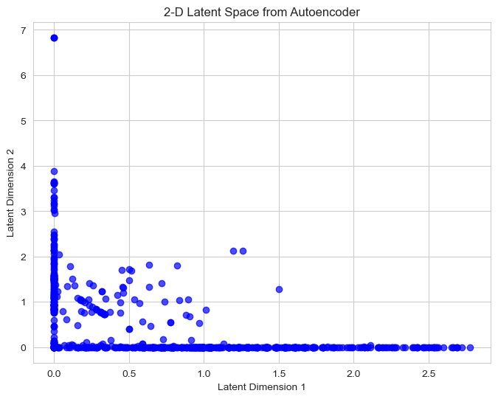
Figure 5: 2D latent space — compressed passenger representations
# Training Loss curve
plt.plot(history.history["loss"], label="Training Loss")
plt.plot(history.history["val_loss"], label="Validation Loss")
plt.title("Autoencoder Training Loss")
plt.legend()
plt.show()
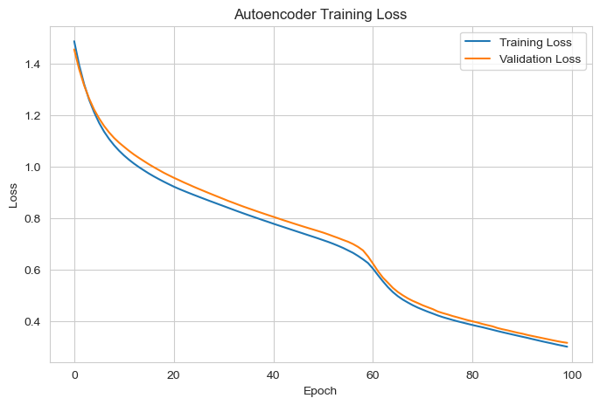
Figure 6: Autoencoder training and validation loss (converging over 100 epochs)
💬 Discussion
The autoencoder compresses 3 features into 2 latent dimensions while preserving key information.
Compression removes redundant information and captures the most meaningful patterns.
The 2D scatter plot makes it easier to identify similar passengers and possible groups.
Low-dimensional representations simplify visualization and improve downstream clustering.

Part 4: Feature Discovery with RBM
Goal: Use a Restricted Boltzmann Machine (RBM) to extract hidden latent features from the autoencoder output. These hidden features represent underlying passenger characteristics like Family Influence and Economic Status.

4.1 Import and Train RBM
from sklearn.neural_network import BernoulliRBM

# Create RBM model
rbm = BernoulliRBM(
n_components=2,
learning_rate=0.01,
batch_size=10,
n_iter=50,
random_state=42
)

# Train on encoded data (from autoencoder)
rbm.fit(encoded_data)

4.2 Extract Latent Features
# Transform encoded data into hidden features
rbm_features = rbm.transform(encoded_data)
print(rbm_features.shape) # (891, 2)

# Add RBM features to original dataframe
df['Family_Influence'] = rbm_features[:, 0]
df['Economic_Status'] = rbm_features[:, 1]

# View feature statistics
df[['Family_Influence', 'Economic_Status']].describe()
Family_Influence Economic_Status
count 8.910000e+02 8.910000e+02
mean 5.296488e-01 5.290118e-01
std 3.942204e-01 3.933956e-01
min 7.646570e-09 9.423092e-09
25% 7.916840e-02 8.000439e-02
50% 6.572668e-01 6.552039e-01
75% 9.005042e-01 8.987866e-01
max 9.996784e-01 9.996598e-01

4.3 Visualize Hidden Features
plt.figure(figsize=(8, 6))
plt.scatter(df["Family_Influence"], df["Economic_Status"], alpha=0.7, color="green")
plt.title("RBM Hidden Features")
plt.xlabel("Family Influence")
plt.ylabel("Economic Status")
plt.show()
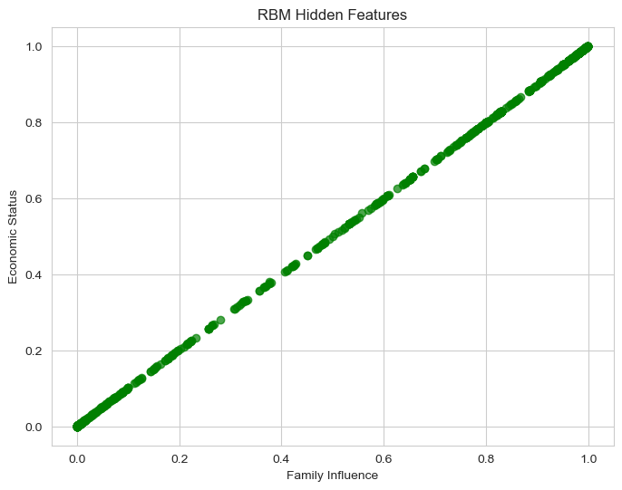
Figure 7: RBM hidden features — Family Influence vs. Economic Status for each passenger
💬 Discussion
RBM discovers hidden patterns not directly visible in the original 3 features.
Hidden features represent underlying characteristics: family ties and economic background.
Latent factors help explain differences in passenger behavior and survival likelihood.
Higher economic status and stronger family-related influence may correlate with survival.

Part 5: Neural Network Prediction
Goal: Use the original features plus the RBM-discovered features to train a Feedforward Neural Network that predicts passenger survival (the Survived column is added back).

5.1 Import Libraries
from sklearn.model_selection import train_test_split
from sklearn.metrics import accuracy_score, confusion_matrix, classification_report
from tensorflow.keras.models import Sequential
from tensorflow.keras.layers import Dense

5.2 Prepare Features and Target
# 5 features: 3 original + 2 RBM-discovered
X = df[['Age', 'Fare', 'Pclass', 'Family_Influence', 'Economic_Status']].copy()
X['Age'] = X['Age'].fillna(X['Age'].median())

# Target variable (re-added)
y = df['Survived']

# Scale and split
X_scaled = scaler.fit_transform(X)
X_train, X_test, y_train, y_test = train_test_split(
X_scaled, y, test_size=0.2, random_state=42
)

5.3 Build Feedforward Neural Network (5→16→8→1)
model = Sequential()
model.add(Dense(16, activation='relu', input_shape=(5,)))
model.add(Dense(8, activation='relu'))
model.add(Dense(1, activation='sigmoid'))

model.compile(
optimizer='adam',
loss='binary_crossentropy',
metrics=['accuracy']
)
model.summary()
Model: "sequential_2"
┏━━━━━━━━━━━━━━━━━━━━━━━━━━━━━━━━━┳━━━━━━━━━━━━━━━━━━━━━━━━┳━━━━━━━━━━━━━━━┓
┃ Layer (type) ┃ Output Shape ┃ Param # ┃
┡━━━━━━━━━━━━━━━━━━━━━━━━━━━━━━━━━╇━━━━━━━━━━━━━━━━━━━━━━━━╇━━━━━━━━━━━━━━━┩
│ dense_8 (Dense) │ (None, 16) │ 96 │
│ dense_9 (Dense) │ (None, 8) │ 136 │
│ dense_10 (Dense) │ (None, 1) │ 9 │
└─────────────────────────────────┴────────────────────────┴───────────────┘
Total params: 241 (964.00 B) | Trainable params: 241

5.4 Train Model (50 Epochs)
history = model.fit(
X_train, y_train,
epochs=50,
batch_size=32,
validation_split=0.2,
verbose=1
)
Epoch 1/50 — accuracy: 0.6169 — loss: 0.7223 — val_accuracy: 0.6503 — val_loss: 0.6628
Epoch 2/50 — accuracy: 0.6169 — loss: 0.6846 — val_accuracy: 0.6503 — val_loss: 0.6436
...
Epoch 50/50 — (converged)

5.5 Evaluate Model
loss, accuracy = model.evaluate(X_test, y_test, verbose=0)
print("Test Accuracy: ", round(accuracy * 100, 2), "%")
Test Accuracy: 75.42 %

5.6 Predictions and Classification Report
y_pred = model.predict(X_test)
y_pred = (y_pred > 0.5).astype(int)

print("Accuracy: ", accuracy_score(y_test, y_pred))

cm = confusion_matrix(y_test, y_pred)
print(cm)

print("Classification Report:")
print(classification_report(y_test, y_pred))
Accuracy: 0.7541899441340782

Confusion Matrix:
[[94 11]
[33 41]]

Classification Report:
precision recall f1-score support

0 0.74 0.90 0.81 105
1 0.79 0.55 0.65 74

accuracy 0.75 179
macro avg 0.76 0.72 0.73 179
weighted avg 0.76 0.75 0.74 179

5.7 Visualizations
# Model Accuracy
plt.plot(history.history["accuracy"], label="Training Accuracy")
plt.plot(history.history["val_accuracy"], label="Validation Accuracy")
plt.title("Model Accuracy")
plt.legend()
plt.show()
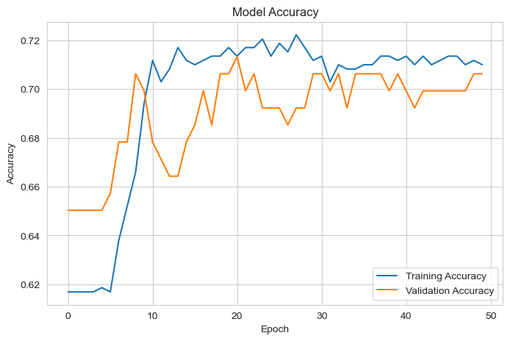
Figure 8: Training vs. Validation Accuracy over 50 epochs
# Training Loss vs Validation Loss
plt.plot(history.history['loss'], label='Training Loss')
plt.plot(history.history['val_loss'], label='Validation Loss')
plt.title('Training Loss vs Validation Loss')
plt.legend()
plt.show()
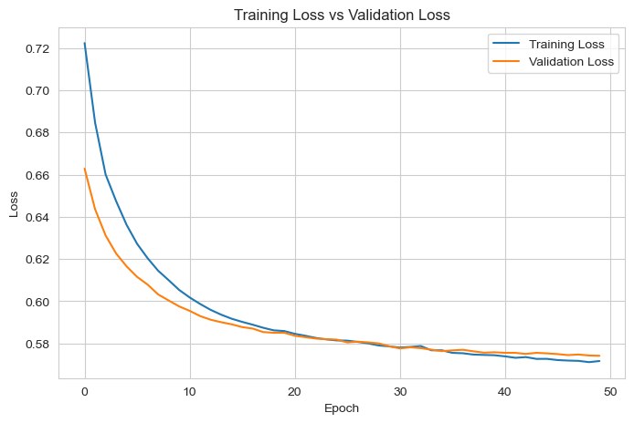
Figure 9: Training and validation loss over epochs
# Actual vs Predicted Survival
plt.scatter(range(len(y_test)), y_test, label='Actual', alpha=0.7)
plt.scatter(range(len(y_pred)), y_pred, label='Predicted', alpha=0.7)
plt.title('Actual vs Predicted Survival')
plt.legend()
plt.show()
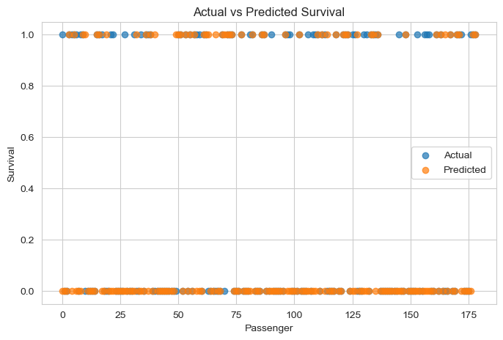
Figure 10: Actual vs. Predicted survival values for test passengers
💬 Discussion
Unsupervised learning (Autoencoder + RBM) extracted hidden patterns before classification.
The discovered latent features captured relationships not visible in the original 3 features.
These additional features (Family_Influence, Economic_Status) improved NN input quality.
Final Test Accuracy: 75.42% — demonstrating the value of the unsupervised pre-processing pipeline.
The model achieved 90% recall for non-survivors (Class 0) and 55% recall for survivors (Class 1).

Summary & Key Findings

Metric | Value / Description
Dataset | 891 passengers, 12 features, Titanic-Dataset.csv
K-Means Clusters | 3 groups — Solo Young Adventurers (463), Families in Steerage (220), Wealthy First-Class (208)
Autoencoder | 3→2→3 architecture, 17 total parameters, 100 epochs, MSE loss converged
RBM Features | BernoulliRBM (2 components), 50 iterations — extracted Family Influence & Economic Status
Neural Network | 5→16→8→1 architecture, 241 parameters, binary cross-entropy, 50 epochs
Final Accuracy | 75.42% on test set (179 passengers)
Precision | Class 0 (non-survivor): 0.74 | Class 1 (survivor): 0.79
Recall | Class 0: 0.90 | Class 1: 0.55 | F1 (macro avg): 0.73

